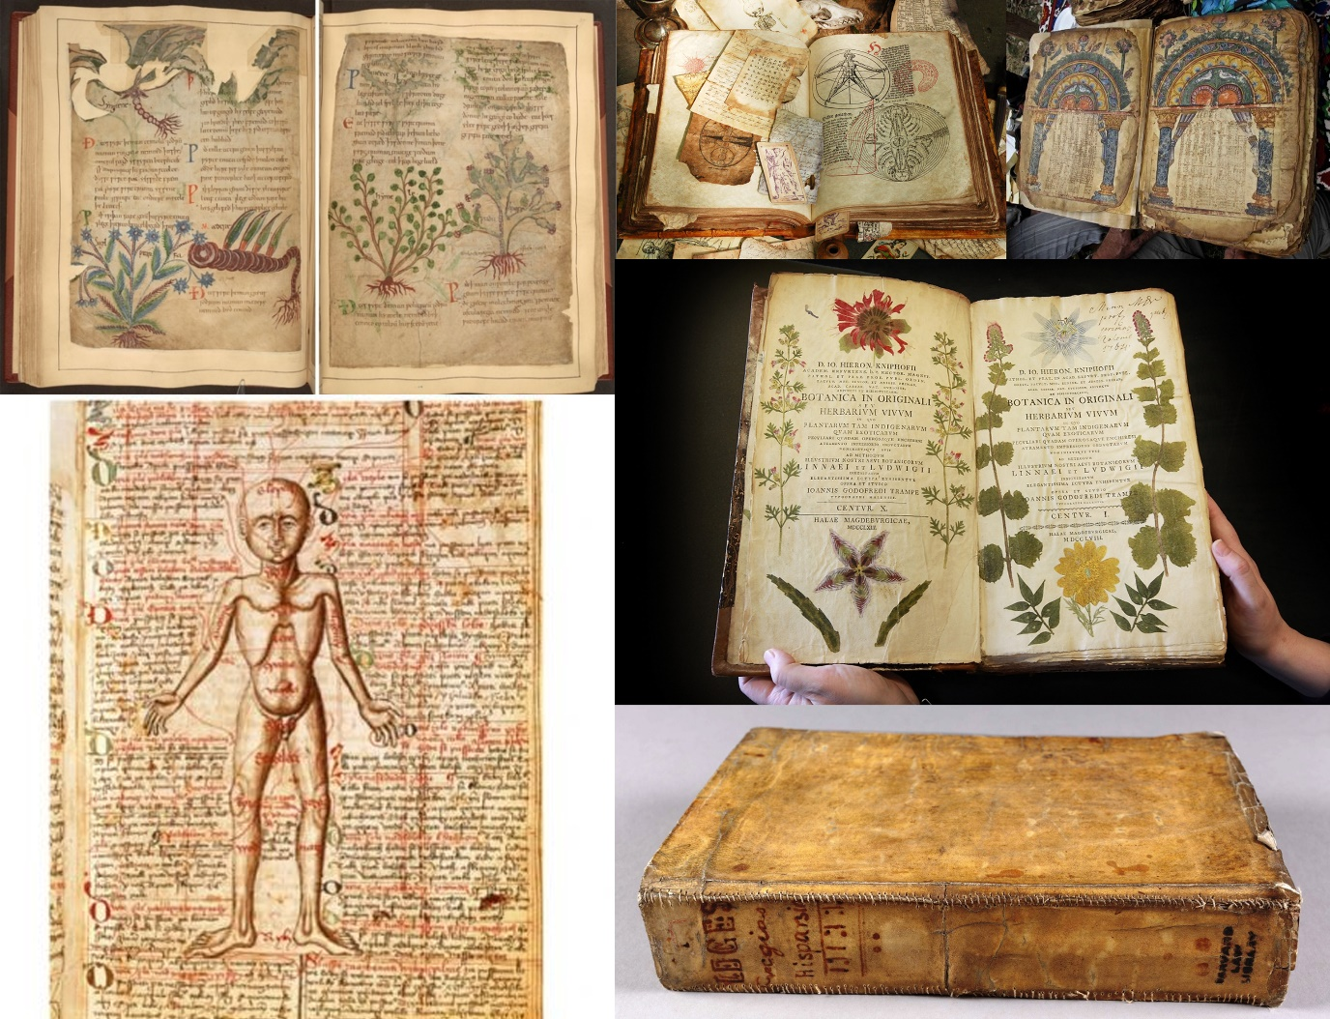

Cure to headaches and pains in the joints:

* Take equal amounts of radish, bishopwort, garlic, wormwood, helenium, cropleek and hollowleek.
* Pound them up, and boil them in butter with celandine and red nettle.
* Keep the mixture in a brass pot until it is a dark red colour.
* Strain it through a cloth and smear on the forehead or aching joints.

Cure to epilepsy, catalepsy and stomach problems

* Liquorice
* Sage
* Willow
* Roses
* Fennel
* Cinnamon
* Ginger
* Clovers
* Cormorant blood
* Mandrake
* Dragon’s blood
* Pepper

For a stye on the eye:

* Onion/leek
* Garlic
* Wine
* Bull’s gall

List of herbs for a medicine garden:

http://blog.english-heritage.org.uk/grow-medieval-herb-garden/

* Sage (Salvia officinalis)
* Betony (Stachys officinalis)
* Clary Sage (Salvia sclarea)
* Hyssop (hysoppus officinalis)
* Rue (Ruta graveolens)
* Chamomile (Chamaemelum nobile)
* Dill (anethum graveolens)
* Cumin (cuminum cyminum)
* Comfrey/ Boneset (Symphytum officinale)

Another list:

<http://www.mostly-medieval.com/explore/plants.htm>

|  |  |
| --- | --- |
| * [Aloe](http://www.mostly-medieval.com/explore/plants2.htm#aloe) * [Angelica](http://www.mostly-medieval.com/explore/plants2.htm#angelica) * [Anise](http://www.mostly-medieval.com/explore/plants2.htm#anise) * [Apple](http://www.mostly-medieval.com/explore/plants2.htm#apple) * [Balm (Melissa)](http://www.mostly-medieval.com/explore/plants2.htm#balm) * [Basil](http://www.mostly-medieval.com/explore/plants2.htm#basil) * [Blackberry](http://www.mostly-medieval.com/explore/plants2.htm#blackberry) * [Buckthorn](http://www.mostly-medieval.com/explore/plants2.htm#buckthorn) * [Burdock](http://www.mostly-medieval.com/explore/plants2.htm#burdock) * [Caraway](http://www.mostly-medieval.com/explore/plants2.htm#caraway) * [Chamomile](http://www.mostly-medieval.com/explore/plants2.htm#chamomile) * [Cinnamon](http://www.mostly-medieval.com/explore/plants2.htm#cinnamon) * [Coltsfoot](http://www.mostly-medieval.com/explore/plants2.htm#coltsfoot) * [Comfrey](http://www.mostly-medieval.com/explore/plants2.htm#comfrey) * [Dandelion](http://www.mostly-medieval.com/explore/plants3.htm#dandelion) * [Dill](http://www.mostly-medieval.com/explore/plants3.htm#dill) * [Elecampane](http://www.mostly-medieval.com/explore/plants3.htm#elecampane) * [Fennel](http://www.mostly-medieval.com/explore/plants3.htm#fennel) * [Fenugreek](http://www.mostly-medieval.com/explore/plants3.htm#fenugreek) | * [Garlic](http://www.mostly-medieval.com/explore/plants3.htm#garlic) * [Horehound](http://www.mostly-medieval.com/explore/plants3.htm#horehound) * [Hyssop](http://www.mostly-medieval.com/explore/plants3.htm#hyssop) * [Licorice](http://www.mostly-medieval.com/explore/plants3.htm#licorice) * [Mint](http://www.mostly-medieval.com/explore/plants3.htm#mint) * [Motherwort](http://www.mostly-medieval.com/explore/plants3.htm#motherwort) * [Myrrh](http://www.mostly-medieval.com/explore/plants3.htm#myrrh) * [Oregano](http://www.mostly-medieval.com/explore/plants4.htm#oregano) * [Parsley](http://www.mostly-medieval.com/explore/plants4.htm#parsley) * [Pennyroyal](http://www.mostly-medieval.com/explore/plants4.htm#pennyroyal) * [Roses](http://www.mostly-medieval.com/explore/plants4.htm#roses) * [Rosemary](http://www.mostly-medieval.com/explore/plants4.htm#rosemary) * [Saffron](http://www.mostly-medieval.com/explore/plants4.htm#saffron) * [Sage](http://www.mostly-medieval.com/explore/plants4.htm#sage) * [St. John's Wort](http://www.mostly-medieval.com/explore/plants4.htm#stjohnswort) * [Thyme](http://www.mostly-medieval.com/explore/plants4.htm#thyme) * [Valerian](http://www.mostly-medieval.com/explore/plants4.htm#valerian) * [Vervain](http://www.mostly-medieval.com/explore/plants4.htm#vervain) * [Yarrow](http://www.mostly-medieval.com/explore/plants4.htm#yarrow) |

References

Abdn.ac.uk. (2017). *What kind of medicines did people use in the Middle Ages?*. [online] Available at: http://www.abdn.ac.uk/sll/disciplines/english/lion/medicine.shtml [Accessed 4 Nov. 2017].

English Heritage Blog. (2017). *What to grow in a medieval herb garden - English Heritage Blog*. [online] Available at: http://blog.english-heritage.org.uk/grow-medieval-herb-garden/ [Accessed 4 Nov. 2017].

History Extra. (2017). *9 weird medieval medicines*. [online] Available at: http://www.historyextra.com/article/medieval/9-weird-medieval-medicines [Accessed 4 Nov. 2017].

My Modern Met. (2017). *1,000-Year-Old Illustrated Manuscript of Herbal Remedies Available Online*. [online] Available at: http://mymodernmet.com/medieval-herbal-remedies-guide-online/ [Accessed 4 Nov. 2017].

old book cover. (2017). [image] Available at: http://etseq.law.harvard.edu/wp-content/uploads/2014/04/Practicarum-Cover-and-Spine.jpg [Accessed 4 Nov. 2017].

old book pages. (2017). [image] Available at: https://www.newstatesman.com/sites/default/files/styles/nodeimage/public/blogs_2015/08/gettyimages-89834936.jpg?itok=vj3UmYoZ [Accessed 4 Nov. 2017].

old book. (2017). [image] Available at: http://manybooks.net/sites/default/files/field/image/43e661787d9f536d01d64877f0001436.jpg [Accessed 4 Nov. 2017].